- 1. How the Program Auto-Detects $x_{min}$ (The Start Fit Position)
The script uses a reverse-search algorithm starting from the peak of your decay data to find where the signal genuinely begins to rise above the background noise. This happens inside the open_fit_dialog function.
Here is the step-by-step logic:
- Background Noise Estimation: The program calculates the mean (bkg_mean) and standard deviation (bkg_std) of the very first portion of your data (either the first 10 points or 5% of the total dataset, whichever is larger).
- Peak Detection: It identifies the maximum count value (peak_val) and exactly where it occurs in time (peak_idx).
- Dynamic Thresholding: It establishes a cutoff threshold to distinguish real signal from noise. This threshold is set to either $3σ$ above the background noise ($bkg_mean + 3 ×bkg_std$) or 1% of the peak maximum—whichever value is higher.
- Backward Tracking: Starting from the peak (peak_idx), the algorithm moves backward in time point-by-point. It stops when the signal intensity drops below the calculated threshold.
- Safety Buffer: Once it finds the threshold crossing point, it steps back an additional 5 data points to ensure the fit captures the absolute beginning of the rising edge, rather than starting halfway up the slope. The time value at this final index becomes your auto_xmin.
- 2. How the Reconvolution Fitting Works
The fitting process relies on a non-linear least-squares optimization that convolves a theoretical decay model with your Instrument Response Function (IRF). This is executed in the run_fitting_process, multi_exp_reconv, and residuals functions.
Here is the sequential workflow of the fit:
Phase A: Initialization
- Masking: The script slices the raw data and IRF arrays to only include the region between your chosen $x_{min}$ and $x_{max}$.
- Parameter Setup: It generates initial guesses for the optimizer. The parameters are stored in a specific order: [shift, background, scatter_amplitude, amplitude_1, tau_1, amplitude_2, tau_2, ...].
- Boundaries: Physical constraints are applied so the optimizer cannot test impossible values (e.g., lifetimes $\left(τ\right)$ and amplitudes must be greater than 0; time shift is bounded to$±50 ns$).
Phase B: The Mathematical Model (Inside the Loop)
During the optimization, the solver repeatedly calls the multi_exp_reconv function, which builds the theoretical curve using the current parameter guesses:
- IRF Shifting: The experimental IRF is shifted left or right by the shift parameter using linear interpolation. This corrects for slight optical or electronic delays between the measurement of the sample and the IRF.
- Ideal Decay Generation: An ideal, multi-exponential decay curve is generated using the current guesses for amplitudes $\left(B\right)$ and lifetimes ($τ$).
- Convolution: The shifted IRF and the ideal decay are convolved together using a Fast Fourier Transform (fftconvolve). FFT is used here because it is computationally much faster than standard discrete convolution for large datasets.
- Scatter and Background: The scatter_amp parameter scales the shifted IRF, adding it directly to the convolved data to account for laser scatter reaching the detector. Finally, a constant bkg (background) is added.
Phase C: Optimization and Weighting
- Poisson Weighting: In time-correlated single-photon counting (TCSPC) or similar measurements, data follows Poisson statistics, meaning the variance equals the number of counts. The residuals function divides the difference between the model and the data by $\sqrt{\text{Counts}}$. This ensures the optimizer does not disproportionately favor fitting the high-count peak at the expense of the low-count tail.
- Minimization: The scipy.optimize.least_squares function tweaks the parameters iteratively until the weighted residuals are minimized and changes between iterations fall below a strict tolerance (1e-6).
Phase D: Result Extraction
Once the best fit is found, the script calculates the reduced Chi-squared $\left(χ^{2}\right)$ to quantify goodness-of-fit. It computes the relative area percentage of each exponential component, updates the plot GUI with the fitted curve and residuals, and stores the parameters in a dataframe for exporting to Excel.

Time-Resolved Photoluminescence (TRPL) Data Analysis
The time-resolved photoluminescence (TRPL) decay profiles of the organic solid-state thin films were analyzed using an iterative reconvolution procedure to meticulously account for the finite instrument response function (IRF). Given the amorphous nature of the organic gain media used for the distributed feedback (DFB) lasers, the photoexcited molecules are situated in highly inhomogeneous microenvironments. This spatial and energetic disorder leads to a continuous distribution of decay rates rather than a discrete single-exponential relaxation. To accurately capture this photophysical behavior, the decay dynamics were modeled using a multiexponential Kohlrausch stretched exponential (also known as stretched exponential function) decay model:
$$I\left(t\right)=\int_{-∞}^{t}{\text{IRF}\left(t^{'}-δ\right)\left[\sum_{i}{B_{i}}\exp\left(-{\left(\frac{t-t^{'}}{τ_{i}}\right)}^{β_{i}}\right)\right]dt^{'}∆t}+A_{sca} IRF \left(t-δ\right)+\text{Background}$$
where $B_{i}$ is the pre-exponential amplitude, $τ_{i}$ is the characteristic relaxation time, and $β_{i}$ $\left(0<β_{i}≤1\right)$ is the stretching exponent for the $i-th$ decay component. The parameter $β_{i}$ serves as a quantitative measure of the structural and energetic disorder within the solid-state thin film; a value of $β_{i}<1$ indicates a deviation from ideal single-exponential behavior due to the distribution of local microenvironments.
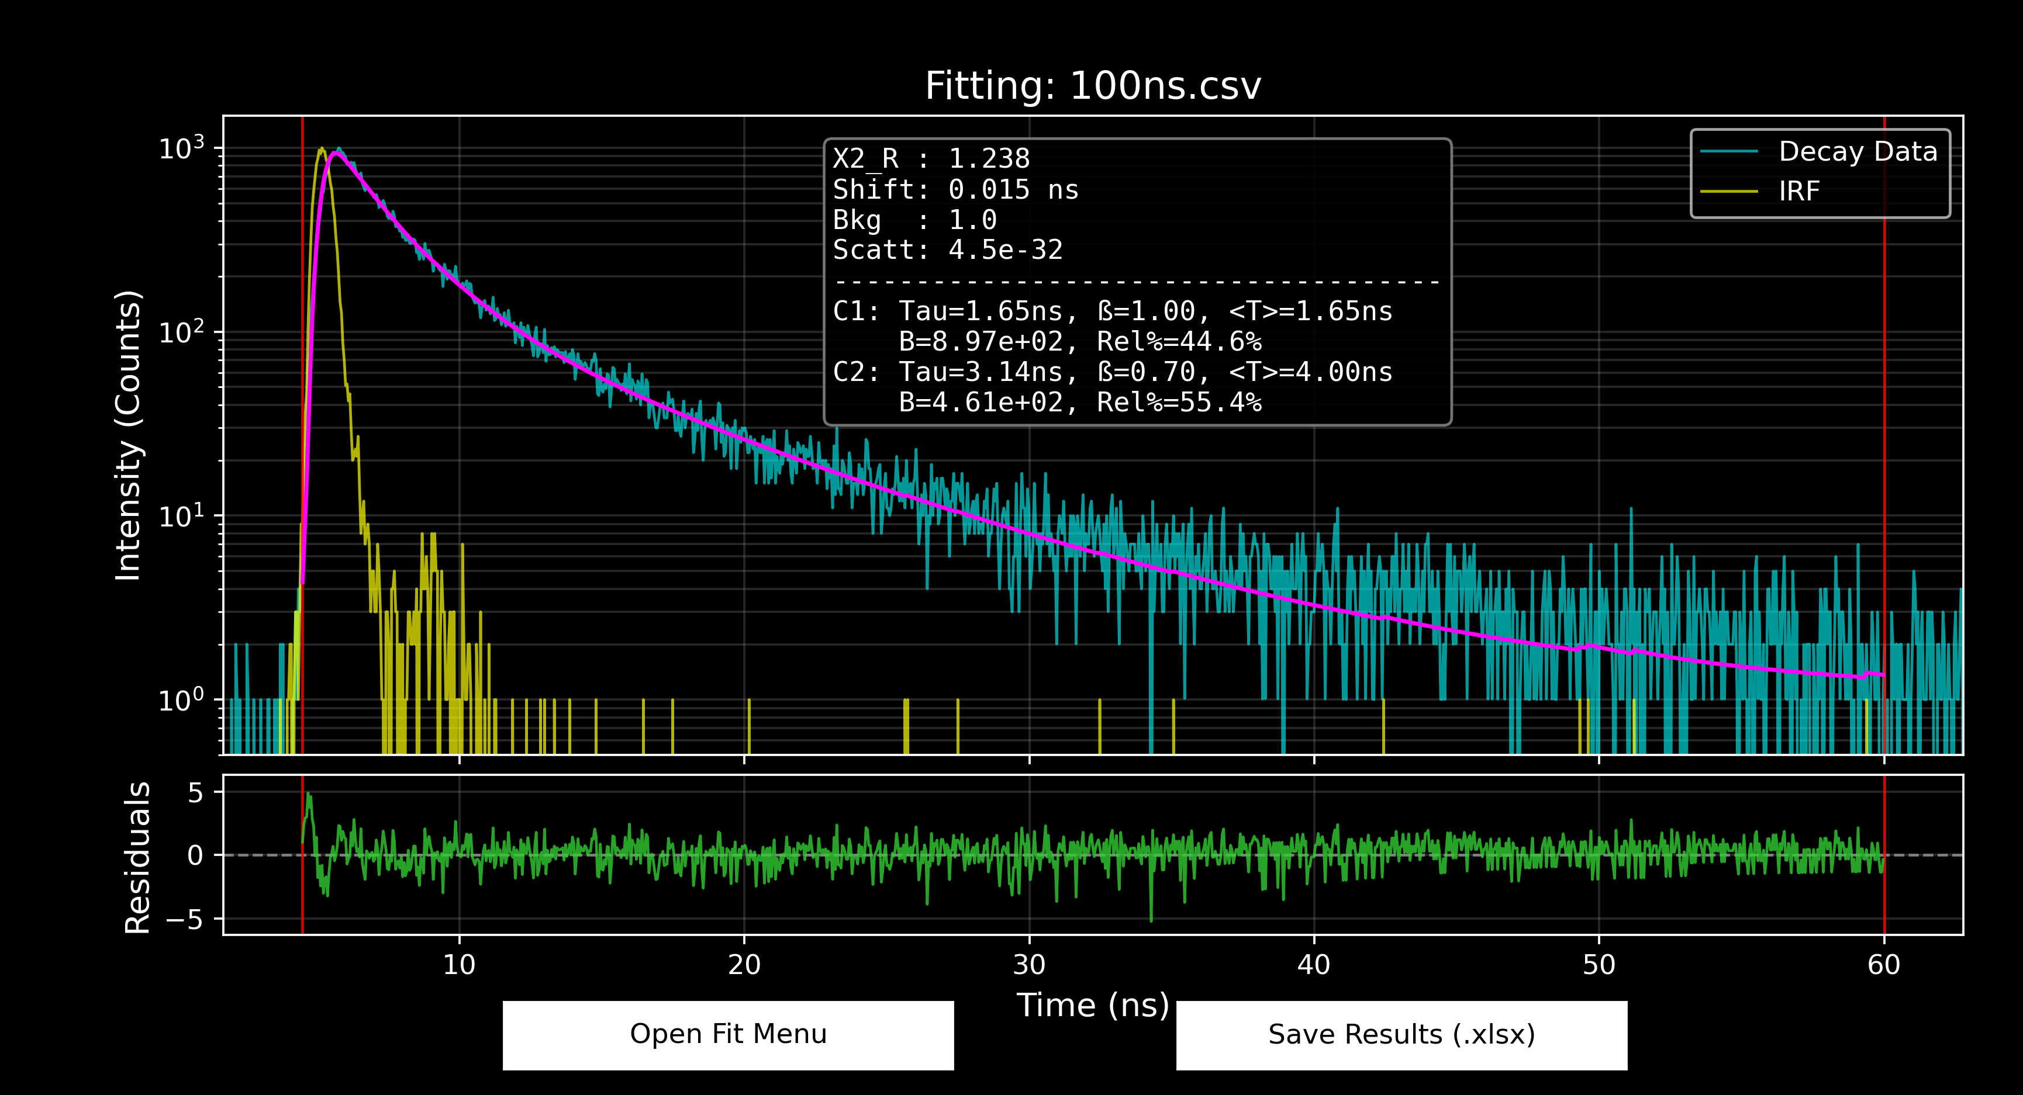
$β$（图中输出的 ß）非常接近 1（比如 0.95 以上），说明这层薄膜的发光物理非常纯粹，环境高度均匀，几乎可以当成完美的单指数衰减。
$β$ 掉到了 0.7 甚至 0.5 以下，即代表固态形貌对 TADF 激子动力学的影响(Inhomogeneous Broadening, morphological disorder)
能重复吗？
这个代表形态无序的发光通道（C2）在宏观统计上是完全可以重复的。
确实，在旋涂固态有机薄膜的过程中，溶剂的快速挥发使得每一个分子的精确空间坐标和局部偶极环境是随机且不可控的。但是，TRPL 测量的是宏观系综（ensemble）的统计行为。只要我们严格控制了旋涂的动力学条件（如溶液浓度、溶剂沸点、转速以及后期的退火温度），薄膜内部无序状态的整体统计分布就是一个稳定的热力学性质。
因此，表征这种无序度分布宽度的拉伸因子 $β$（约 0.7），以及该无序状态在总发光中的相对权重（约 55%），在不同批次制备的同规格薄膜中，其数值会在一个很小的合理误差范围内保持高度一致。

Because the stretched exponential decay lacks a single discrete lifetime, the physically meaningful effective lifetime for each emission channel was evaluated by calculating the mean relaxation time $\left\langle τ_{i}\right\rangle$ using the Gamma function:
$$\left\langle τ_{i}\right\rangle =\frac{τ_{i}}{β_{i}}Γ\left(\frac{1}{β_{i}}\right)$$
For our TADF-based gain media, resolving the precise prompt and delayed mean relaxation times $\left(\left\langle τ\right\rangle \right)$ is crucial for calculating the intersystem crossing (ISC) and reverse intersystem crossing (RISC) rates, which ultimately dictates the viability of triplet harvesting for sustaining population inversion and optical gain. The goodness-of-fit was rigorously evaluated by minimizing the reduced chi-squared $\left(χ_{R}^{2}\right)$ value close to 1.0 and ensuring a random distribution of the weighted residuals.

